11
Bioavailability and Bioequivalence
The therapeutic effectiveness of a drug depends upon the ability of the dosage form to deliver the medicament to its site of action at a rate and amount sufficient to elicit the desired pharmacological response. This attribute of the dosage form is referred to as physiological availability, biological availability or simply, bioavailability. For most drugs, the pharmacological response can be related directly to the plasma levels. Thus, the term bioavailability is defined as the rate and extent (amount) of absorption of unchanged drug from its dosage form. It is an absolute term. The rate or rapidity with which a drug is absorbed is an important consideration when a rapid onset of action is desired as in the treatment of acute conditions such as asthma attack, pain, etc. A slower absorption rate is, however, desired when the aim is to prolong the duration of action or to avoid the adverse effects. On the other hand, extent of absorption is of special significance in the treatment of chronic conditions like hypertension, epilepsy, etc.
If the size of the dose to be administered is same, then bioavailability of a drug from its dosage form depends upon 3 major factors:
- Pharmaceutical factors related to physicochemical properties of the drug and characteristics of the dosage form.
- Patient related factors.
- Route of administration.
The former two factors have been dealt with comprehensively in Chapter 2 on Absorption of Drugs. The influence of route of administration on drug's bioavailability is generally in the following order with few exceptions:
Parenteral > Oral > Rectal > Topical
Within the parenteral route, intravenous injection of a drug results in 100% bioavailability as the absorption process is bypassed. However, for reasons of stability and convenience, most drugs are administered orally. In such cases, the dose available to the patient, called as the bioavailable dose, is often less than the administered dose. The amount of drug that reaches the systemic circulation (i.e. extent of absorption) is called as systemic availability or simply availability. The term bioavailable fraction F, refers to the fraction of administered dose that enters the systemic circulation.
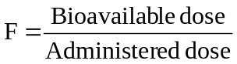 | (11.1)
Objectives of Bioavailability Studies
Bioavailability studies are important in the —
- Primary stages of development of a suitable dosage form for a new drug entity to obtain evidence of its therapeutic utility.
- Determination of influence of excipients, patient related factors and possible interaction with other drugs on the efficiency of absorption.
- Development of new formulations of the existing drugs.
- Control of quality of a drug product during the early stages of marketing in order to determine the influence of processing factors, storage and stability on drug absorption.
- Comparison of availability of a drug substance from different dosage forms or from the same dosage form produced by different manufacturers.

CONSIDERATIONS IN IN-VIVO BIOAVAILABILITY STUDY DESIGN
Bioavailability—Absolute versus Relative
When the systemic availability of a drug administered orally is determined in comparison to its intravenous administration, it is called as absolute bioavailability. It is denoted by symbol F. Its determination is used to characterize a drug’s inherent absorption properties from the e.v. site. Intravenous dose is selected as a standard because the drug is administered directly into the systemic circulation (100% bioavailability) and avoids absorption step. Intramuscular dose can also be taken as a standard if the drug is poorly water-soluble. An oral solution as reference standard has also been used in certain cases. However, there are several drawbacks of using oral solution as a standard instead of an i.v. dose —
- Limits the pharmacokinetic treatment to one-compartment model only; one cannot apply the most applicable two-compartment kinetics to the data and all pharmacokinetic parameters cannot be assessed.
- Differentiation between the fraction of dose unabsorbed and that metabolised is difficult.
- If the rate of oral absorption is not sufficiently greater than the rate of elimination, the true elimination rate constant cannot be computed.
At best, when oral solution is used in conjunction with i.v. route, one can distinguish the dissolution rate limitation in drug absorption from solid dosage forms.
When the systemic availability of a drug after oral administration is compared with that of an oral standard of the same drug (such as an aqueous or non-aqueous solution or a suspension), it is referred to as relative or comparative bioavailability. It is denoted by symbol Fr. In contrast to absolute bioavailability, it is used to characterize absorption of a drug from its formulation. F and Fr are generally expressed in percentages.
Single Dose versus Multiple Dose Studies
The dose to be administered for a bioavailability study is determined from preliminary clinical experiments. Single dose bioavailability studies are very common. They are easy, offer less exposure to drugs and are less tedious. However, it is difficult to predict the steady-state characteristics of a drug and inter-subject variability with such studies. Moreover, sufficiently long sampling periods are necessary in order to get reliable estimates of terminal half-life, which is needed for correct calculation of the total AUC. The better alternative is thus, multiple dose study which offers several advantages —
- More accurately reflects the manner in which the drug will be used clinically.
- Allows blood levels to be measured at the same concentrations encountered therapeutically.
- Easy to predict the peak and valley characteristics of drug since the bioavailability is determined at steady-state.
- Requires collection of fewer blood samples.
- The drug blood levels are higher due to cumulative effect which makes its determination possible even by the less sensitive analytic methods.
- Can be ethically performed in patients because of the therapeutic benefit to the patient.
- Small inter-subject variability is observed in such a study which allows use of fewer subjects.
- Better evaluation of the performance of a controlled-release formulation is possible.
- Nonlinearity in pharmacokinetics, if present, can be easily detected.
- Eliminates the need for a long wash-out period between doses. Moreover, the switch-over from one formulation to the other is possible at steady state.

Limitations of multiple-dose studies include –
  - Tedious, requires more time to complete.
  - More difficult and costly to conduct (requires prolonged monitoring of subjects).
  - Poor compliance by subjects.
  - Greater exposure of subjects to the test drug, increasing the potential for adverse reactions.
In multiple dose study, one must ensure that the steady-state has been reached. For this, the drug should be administered for 5 to 6 elimination half-lives before collecting the blood samples.
Human Volunteers—Healthy Subjects versus Patients
Ideally, the bioavailability study should be carried out in patients for whom the drug is intended to be used because of apparent advantages—
- The patient will be benefited from the study.
- Reflects better the therapeutic efficacy of a drug.
- Drug absorption pattern in disease states can be evaluated.
- Avoids the ethical quandary of administering drugs to healthy subjects.
Patients are generally preferred in multiple dose bioavailability studies. The drawbacks of using patients as volunteers are equally large—disease, other drugs, physiologic changes, etc. may modify the drug absorption pattern. Stringent study conditions such as fasting state required to be followed by the subject is also difficult. In short, establishing a standard set of conditions necessary for a bioavailability study is difficult with patients as volunteers. Such studies are therefore usually performed in young (20 to 40 years), healthy, male adult volunteers (body weight within a narrow range; ± 10%), under restricted dietary and fixed activity conditions. Female volunteers are used only when drugs such as oral contraceptives are to be tested. The number of subjects to be selected depends upon the extent of inter-subject variability but should be kept to a minimum required to obtain a reliable data. The consent of volunteers must be obtained and they must be informed about the importance of the study, conditions to be followed during the study and possible hazards if any, prior to starting the study. Medical examination should be performed in order to exclude subjects with any kind of abnormality or disease. The volunteers must be instructed to abstain from any medication for at least a week and to fast overnight prior to and for a minimum of 4 hours after dosing. The volume and type of fluid and the standard diet to be taken must also be specified. Drug washout period for a minimum of ten biological half-lives must be allowed for between any two studies in the same subject.
Measurement of Bioavailability
The methods useful in quantitative evaluation of bioavailability can be broadly divided into two categories — pharmacokinetic methods and pharmacodynamic methods.
- Pharmacokinetic Methods
These are very widely used and based on the assumption that the pharmacokinetic profile reflects the therapeutic effectiveness of a drug. Thus, these are indirect methods. The two major pharmacokinetic methods are:
- Plasma level-time studies.
- Urinary excretion studies.
- Pharmacodynamic Methods
These methods are complementary to pharmacokinetic approaches and involve direct measurement of drug effect on a (patho)physiological process as a function of time. The two pharmacodynamic methods involve determination of bioavailability from:
- Acute pharmacological response.
- Therapeutic response.
Plasma Level—Time Studies
Unless determination of plasma drug concentration is difficult or impossible, it is the most reliable method and method of choice in comparison to urine data. The method is based on the assumption that two dosage forms that exhibit superimposable plasma level-time profiles in a group of subjects should result in identical therapeutic activity.
With single dose study, the method requires collection of serial blood samples for a period of 2 to 3 biological half-lives after drug administration, their analysis for drug concentration and making a plot of concentration versus corresponding time of sample collection to obtain the plasma level-time profile. With i.v. dose, sampling should start within 5 minutes of drug administration and subsequent samples taken at 15 minute intervals. To adequately describe the disposition phase, at least 3 sample points should be taken if the drug follows one-compartment kinetics and 5 to 6 points if it fits two-compartment model. For oral dose, at least 3 points should be taken on the ascending part of the curve for accurate determination of Ka. The points for disposition or descending phase of the curve must be taken in a manner similar to that for i.v. dose.
The 3 parameters of plasma level-time studies which are considered important for determining bioavailability are:
- Cmax: The peak plasma concentration that gives an indication whether the drug is sufficiently absorbed systemically to provide a therapeutic response. It is a function of both the rate and extent of absorption. C_{max} will increase with an increase in the dose, as well as with an increase in the absorption rate.
- tmax: The peak time that gives an indication of the rate of absorption. It decreases as the rate of absorption increases.
- AUC: The area under the plasma level-time curve that gives a measure of the extent of absorption or the amount of drug that reaches the systemic circulation.
The extent of bioavailability can be determined by following equations:
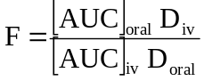 | (11.2)
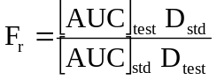 | (11.3)
where D stands for dose administered and subscripts iv and oral indicate the route of administration. Subscripts test and std indicate the test and the standard doses of the same drug to determine relative availability. The rate of absorption can be computed from one of the several methods discussed in Chapter 9.
With multiple dose study, the method involves drug administration for at least 5 biological half-lives with a dosing interval equal to or greater than the biological half-life (i.e. administration of at least 5 doses) to reach the steady-state. A blood sample should be taken at the end of previous dosing interval and 8 to 10 samples after the administration of next dose. The extent of bioavailability is given as:
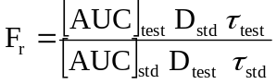 | (11.4)
where [AUC] values are area under the plasma level-time curve of one dosing interval in a multiple dosage regimen, after reaching the steady-state (Fig. 11.1) and τ is the dosing interval.
Bioavailability can also be determined from the peak plasma concentration at steady-state Css,max according to following equation:
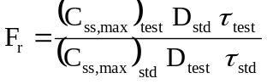 | (11.5)
The rate of absorption is not important in the multiple dosing methods.
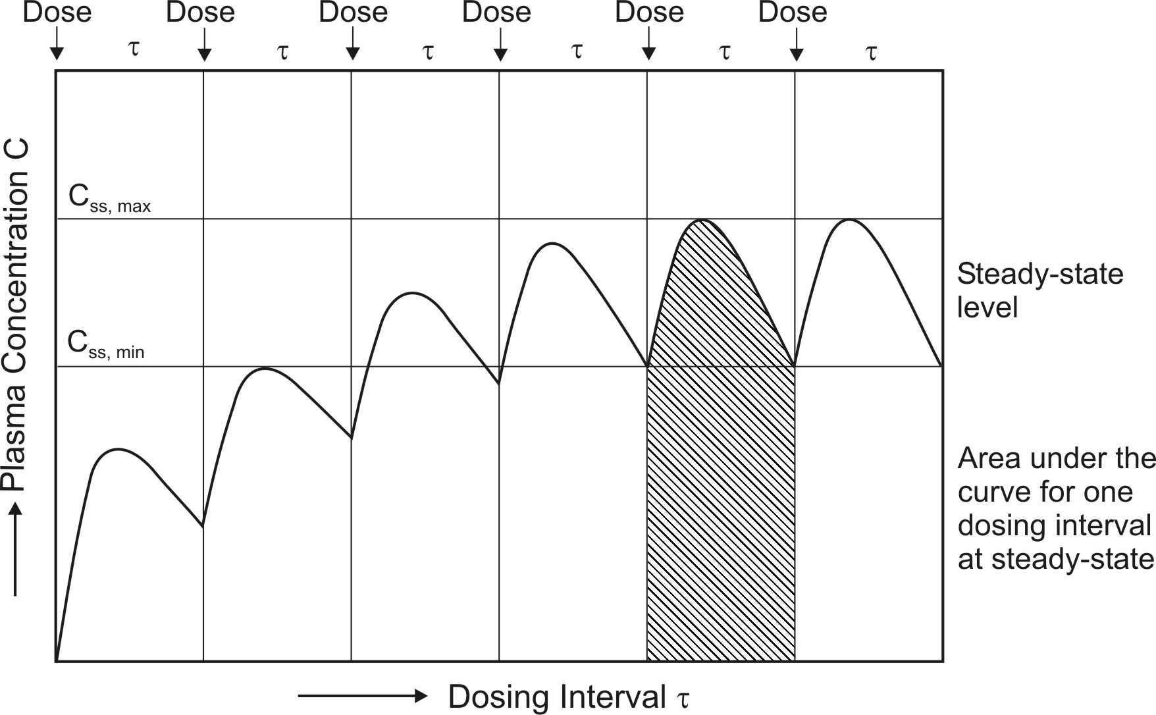
Fig. 11.1 Determination of AUC and Css,max on multiple dosing upto steady-state
Urinary Excretion Studies
This method of assessing bioavailability is based on the principle that the urinary excretion of unchanged drug is directly proportional to the plasma concentration of drug. As a rule of thumb, determination of bioavailability using urinary excretion data should be conducted only if at least 20% of administered dose is excreted unchanged in the urine. The study is particularly useful for –
- Drugs extensively excreted unchanged in the urine – for example, certain thiazide diuretics and sulphonamides.
- Drugs that have urine as the site of action - for example, urinary antiseptics such as nitrofurantoin and hexamine.
The method has several advantages and disadvantages as discussed in Chapter 9. Concentration of metabolites excreted in urine is never taken into account in calculations since a drug may undergo presystemic metabolism at different stages before being absorbed. The method involves –
- Collection of urine at regular intervals for a time-span equal to 7 biological half-lives.
- Analysis of unchanged drug in the collected sample.
- Determination of the amount of drug excreted in each interval and cumulative amount excreted.
For obtaining valid results, following criteria must be met further –
- At each sample collection, total emptying of the bladder is necessary to avoid errors resulting from addition of residual amount to the next urine sample.
- Frequent sampling of urine is also essential in the beginning in order to compute correctly the rate of absorption.
- The fraction excreted unchanged in urine must remain constant.
The three major parameters examined in urinary excretion data obtained with a single dose study are:
  - (dXu/dt)max: The maximum urinary excretion rate, it is obtained from the peak of plot between rate of excretion versus midpoint time of urine collection period. It is analogous to the Cmax derived from plasma level studies since the rate of appearance of drug in the urine is proportional to its concentration in systemic circulation. Its value increases as the rate of and/or extent of absorption increases (see Fig. 11.2).
  - (tu)max: The time for maximum excretion rate, it is analogous to the tmax of plasma level data. Its value decreases as the absorption rate increases.
  - Xu∞: The cumulative amount of drug excreted in the urine, it is related to the AUC of plasma level data and increases as the extent of absorption increases.
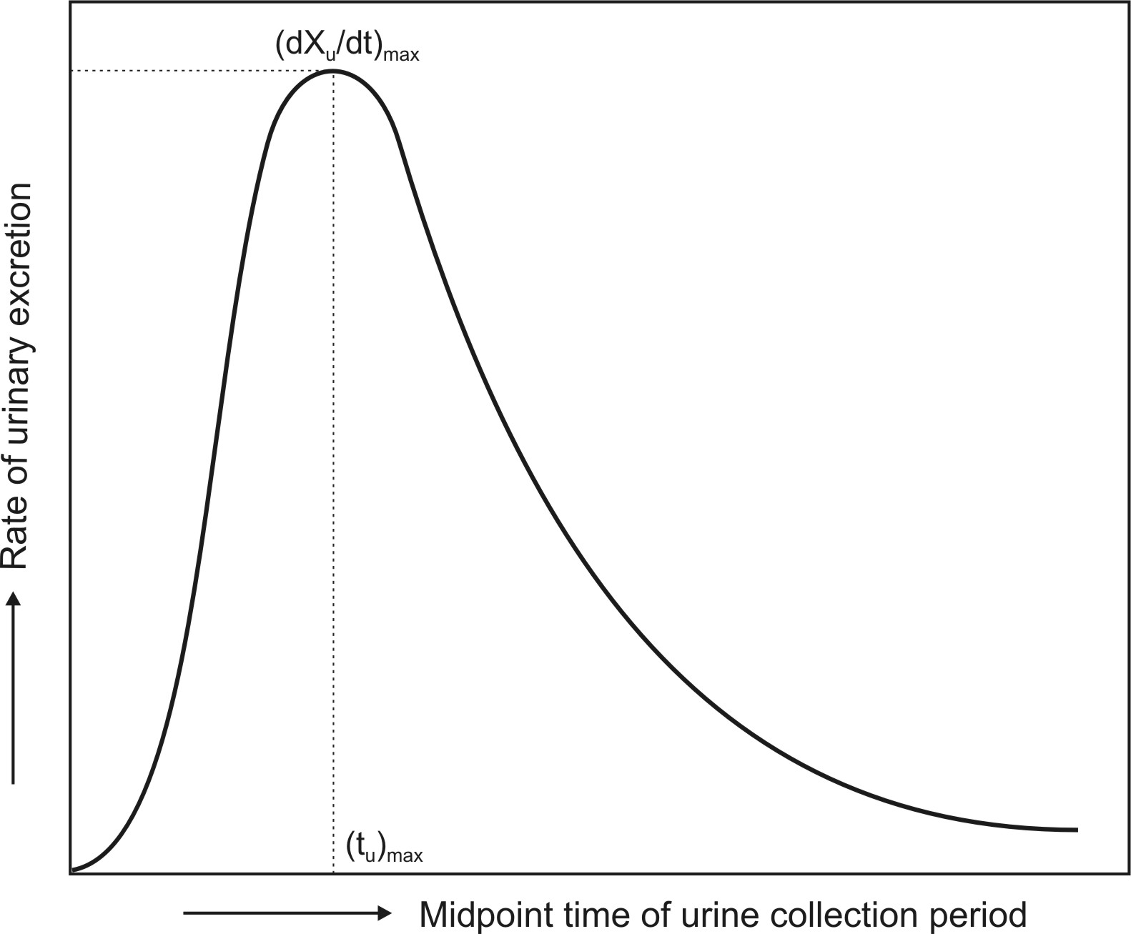
Fig. 11.2 Plot of urinary excretion rate versus time. Note that the curve is analogous to a typical plasma level-time profile obtained after oral administration of a single dose of drug.
The extent of bioavailability is calculated from equations given below:
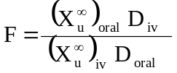 | (11.6)
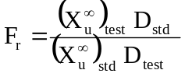 | (11.7)
With multiple dose study to steady-state, the equation for computing bioavailability is:
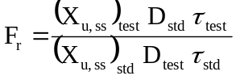 | (11.8)
where (Xu,ss) is the amount of drug excreted unchanged during a single dosing interval at steady-state.
In practice, estimation of bioavailability by urinary excretion method is subject to a high degree of variability, and is less reliable than those obtained from plasma concentration-time profiles. It is thus not recommended as a substitute for blood concentration data; rather, it should be used in conjunction with blood level data for confirmatory purposes.
Bioavailability can also be determined for a few drugs by assay of biologic fluids other than plasma and urine. In case of theophylline, salivary excretion can be used whereas for cephalosporin antibiotics, appearance of drug in CSF and bile can be determined. Caution must however be exercised to account for salivary and enterohepatic cycling of the drugs.
Acute Pharmacological Response Method
When bioavailability measurement by pharmacokinetic methods is difficult, inaccurate or non-reproducible, an acute pharmacological effect such as a change in ECG or EEG readings, pupil diameter, etc. is related to the time course of a given drug. Bioavailability can then be determined by construction of pharmacological effect-time curve as well as dose-response graphs. The method requires measurement of responses for at least 3 biological half-lives of the drug in order to obtain a good estimate of AUC.
Disadvantages of this method include –
- The pharmacological response tends to be more variable and accurate correlation between measured response and drug available from the formulation is difficult.
- The observed response may be due to an active metabolite whose concentration is not proportional to the concentration of parent drug responsible for the pharmacological effect.
Therapeutic Response Method
Theoretically the most definite, this method is based on observing the clinical response to a drug formulation given to patients suffering from disease for which it is intended to be used. However, the method has several drawbacks –
  - Quantitation of observed response is too improper to allow for reasonable assessment of relative bioavailability between two dosage forms of the same drug.
  - Bioequivalence studies are usually conducted using a crossover design in which each subject receives each of the test dosage forms, and it is assumed that the physiological status of the subject does not change significantly over the duration of the study.
  - Unless multiple-dose protocols are employed, a patient who required the drug for a disease would be able to receive only a single dose of the drug every few days or perhaps each week.
  - Many patients receive more than one drug, and the results obtained from a bioavailability study could be compromised because of a drug–drug interaction.
Because of the above considerations, the general conclusion is that most bioavailability/bioequivalence studies should be carried out in healthy subjects. However, for drugs that are not designed to be absorbed into the systemic circulation and are active at the site of administration, clinical studies in patients are the only means to determine bioequivalence. Such studies are usually conducted using a parallel, rather than a crossover design. Examples include studies of topical antifungal agents, drugs used in the treatment of acne and agents such as sucralfate used in ulcer therapy.

In Vitro Drug Dissolution Rate and Bioavailability
The physicochemical property of most drugs that has greatest influence on their absorption characteristics from the GIT is dissolution rate. The best way of assessing therapeutic efficacy of drugs with a slow dissolution rate is in vivo determination of bioavailability which is usually done whenever a new formulation is to be introduced into the market. However, monitoring batch-to-batch consistency through use of such in vivo tests is extremely costly, tedious and time consuming besides exposing the healthy subjects to hazards of drugs. It would therefore be always desirable to substitute the in vivo bioavailability tests with inexpensive in vitro methods. The simple in vitro disintegration test is unreliable. The best available tool today which can at least quantitatively assure about the biologic availability of a drug from its formulation is its in vitro dissolution test.
In Vitro Drug Dissolution Testing Models
For an in vitro test to be useful, it must predict the in vivo behaviour to such an extent that in vivo bioavailability test need not be performed. Despite attempts to standardize the test performance, the in vitro dissolution technique is still by no means a perfect approach. The efforts are mainly aimed at mimicking the environment offered by the biological system.
There are several factors that must be considered in the design of a dissolution test. They are –
- Factors relating to the dissolution apparatus such as—the design, the size of the container (several mL to several litres), the shape of the container (round bottomed or flat), nature of agitation (stirring, rotating or oscillating methods), speed of agitation, performance precision of the apparatus, etc.
- Factors relating to the dissolution fluid such as—composition (water, 0.1N HCl, phosphate buffer, simulated gastric fluid, simulated intestinal fluid, etc.), viscosity, volume (generally larger than that needed to completely dissolve the drug under test), temperature (generally 37oC) and maintenance of sink (drug concentration in solution maintained constant at a low level) or non-sink conditions (gradual increase in the drug concentration in the dissolution medium).
- Process parameters such as method of introduction of dosage form, sampling techniques, changing the dissolution fluid, etc.
The ideal features of a dissolution apparatus are:
- The fabrication, dimensions, and positioning of all components must be precisely specified and reproducible, run-to-run.
- The apparatus must be simple in design, easy to operate and useable under a variety of conditions.
- The apparatus must be sensitive enough to reveal process changes and formulation differences but still yield repeatable results under identical conditions.
- The apparatus, in most cases, should permit controlled variable intensity of mild, uniform, non-turbulent liquid agitation.
- Nearly perfect sink conditions should be maintained.
- The apparatus should provide an easy means of introducing the dosage form into the dissolution medium and holding it, once immersed, in a regular reliable fashion.
- The apparatus should provide minimum mechanical abrasion to the dosage form during the test period to avoid disruption of the microenvironment surrounding the dissolving form.
- Evaporation of the solvent medium must be eliminated, and the medium must be maintained at a fixed temperature within a specified narrow range. Most apparatuses are thermostatically controlled at around 37°C.
- Samples should be easily withdrawn for automatic or manual analysis without interrupting the flow characteristics of the liquid.
- The apparatus should be capable of allowing the evaluation of disintegrating, non-disintegrating, dense or floating tablets or capsules, and finely powdered drugs.
- The apparatus should allow good inter-laboratory agreement.
The dissolution apparatus has evolved gradually and considerably from a simple beaker type to a highly versatile and fully automated instrument. The devices can be classified in a number of ways. Based on the absence or presence of sink conditions, there are two principal types of dissolution apparatus:
1. Closed-compartment apparatus: It is basically a limited-volume apparatus operating under non-sink conditions. The dissolution fluid is restrained to the size of the container, e.g. beaker type apparatuses such as the rotating basket and the rotating paddle apparatus.
2. Open-compartment (continuous flow-through) apparatus: It is the one in which the dosage form is contained in a column which is brought in continuous contact with fresh, flowing dissolution medium (perfect sink condition).
A third type called as dialysis systems are used for very poorly aqueous soluble drugs for which maintenance of sink conditions would otherwise require large volume of dissolution fluid. Only the official or compendial methods (USP methods) will be discussed here briefly.
Rotating Basket Apparatus (Apparatus 1)
First described by Pernarowski et al, it is basically a closed-compartment, beaker type apparatus comprising of a cylindrical glass vessel with hemispherical bottom of one litre capacity partially immersed in a water bath to maintain the temperature at 37oC. A cylindrical basket made of 22 mesh to hold the dosage form is located centrally in the vessel at a distance of 2 cm from the bottom and rotated by a variable speed motor through a shaft (Fig. 11.3a). The basket should remain in motion during drawing of samples. All metal parts like basket and shaft are made of SS 316.
Rotating Paddle Apparatus (Apparatus 2)
The assembly is same as that for apparatus 1 except that the rotating basket is replaced with a paddle which acts as a stirrer (Fig. 11.3b). The method was first described by Levy and Hayes. The dosage form is allowed to sink to the bottom of the vessel. Sinkers are recommended to prevent floating of capsules and other floatable forms. A small, loose, wire helix may be attached to such preparations to prevent them from floating.

Reciprocating Cylinder Apparatus (Apparatus 3)
This apparatus consists of a set of cylindrical flat-bottomed glass vessels equipped with reciprocating cylinders (Fig. 11.3c). The apparatus is particularly used for dissolution testing of controlled release bead-type (pellet) formulations.

Flow-Through Cell Apparatus (Apparatus 4)
The flow-through apparatus consists of a reservoir for the dissolution medium and a pump that forces dissolution medium through the cell holding the test sample. It may be used in either –
- Closed-mode where the fluid is recirculated and, by necessity, is of fixed volume, or
- Open-mode when there is continuous replenishment of the fluids.
The material under test (tablet, capsules, or granules) is placed in the vertically mounted dissolution cell, which permits fresh solvent to be pumped (between 240 and 960 mL/h) in from the bottom (Fig. 11.3d). Advantages of this apparatus include –
- Easy maintenance of sink conditions for dissolution which is often required for drugs having limited aqueous solubility.
- Feasibility of using large volume of dissolution fluid.
- Feasibility for automation of apparatus.

Paddle Over Disc Apparatus (Apparatus 5)
This apparatus is used for evaluation of transdermal products and consists of a sample holder or disc that holds the product. The disc is placed at the bottom of apparatus 2 (rotating paddle apparatus; see fig. 11.3e) and the apparatus operated in the usual way.

Cylinder Apparatus (Apparatus 6)
This apparatus is also used for evaluation of transdermal products and is similar to apparatus 1 (Fig. 11.3f). Instead of basket, a stainless steel cylinder is used to hold the sample. The sample is mounted on an inert porous cellulosic material and adhered to the cylinder.

Reciprocating Disc Apparatus (Apparatus 7)
This apparatus is used for evaluation of transdermal products as well as non-disintegrating controlled-release oral preparations. The samples are placed on disc-shaped holders (Fig. 11.3g) using inert porous cellulosic support which reciprocates vertically by means of a drive inside a glass container containing dissolution medium. The test is carried out at 32⁰C and reciprocating frequency of 30 cycles/min.

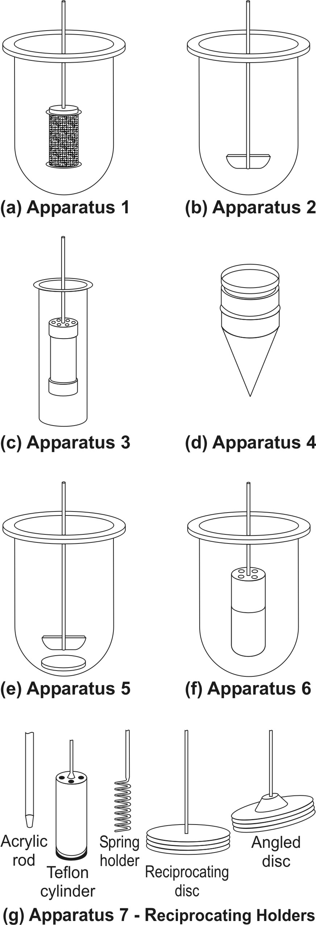
Fig. 11.3 Schematic representation of official USP dissolution apparatus - (a) Apparatus 1 - rotating basket apparatus, (b) Apparatus 2 - rotating paddle apparatus, (c) Apparatus 3 – reciprocating cylinder apparatus, (d) Apparatus 4 – flow through cell apparatus, (e) Apparatus 5 – paddle over disc apparatus, (f) Apparatus 6 – cylinder apparatus, and (g) Apparatus 7 – reciprocating disc apparatus

Table 11.1 lists the various types of dissolution apparatus and their applications, and table 11.2 summarises the dissolution methodology to be adopted for immediate-release products on the basis of BCS.
Table 11.1.

Compendial Dissolution Apparatus Types and Their Applications
Apparatus | Name | Drug Formulation Tested
Apparatus 1 | Rotating basket | Conventional Tablets
Apparatus 2 | Rotating paddle | Tablets, capsules, controlled release products, suspensions
Apparatus 3 | Reciprocating cylinder | Controlled release formulations
Apparatus 4 | Flow-through cell | Formulations containing poorly soluble drugs
Apparatus 5 | Paddle over disc | Transdermal formulations
Apparatus 6 | Cylinder | Transdermal formulations
Apparatus 7 | Reciprocating disc | Controlled release formulations

Table 11.2.

Dissolution Methodology for Immediate-Release Products Based on BCS
BCS Class | Dissolution Methodology
I | Single point if NLT 85% Q in 15 minutes  Multiple point if Q < 85% in 15 minutes
II | Multiple point
III | Same as class I
1V | Same as class II

Dissolution Acceptance Criteria
On the basis of dissolution profile data, criteria for acceptance/passing of test results are based on Q values as given in table 11.3. The value of Q is defined as percentage of drug content dissolved in a given time period. This value is generally specified in USP monograph of a given drug product. Three stages viz. S₁, S₂ and S₃ of dissolution testing are allowed as given in table 11.3.
In the first stage of the USP dissolution test consists of testing six dosage units. If all of the dosage units are greater than or equal to Q+5%, then the dissolution test criteria are met and the test is passed. However, if this criterion is not met, six additional dosage units are tested and compared to the acceptance criteria for the twelve dosage units. To pass at the second stage, the average of the twelve dosage units must be equal to or greater than Q and no dosage unit can be less than Q-15%. If both of the above criteria are not met at the second stage, the final stage of testing is performed. Twelve additional dosage units are evaluated, providing a total of twenty four results. To pass at this final stage of testing, the average of the twenty four dosage units must be equal to or greater than Q, not more than two dosage units can be less than Q - 15 %, and no dosage unit can be less than Q-25%.
Table 11.3.
Dissolution Acceptance Criteria
Stage | Number of Dosage Units Tested | Acceptance Criteria
S₁ | 6 | No dosage unit is less than Q+5%
S₂ | 6 | Average of the twelve dosage units (S₁ + S₂) ≥ Q% and no dosage unit is less than Q-15%
S₃ | 12 | Average of the twenty four dosage units (S₁ + S₂ ₊ S₃) ≥ Q% and not more than two dosage units are less than Q-15% and no dosage unit is less than Q-25%

Objectives of Dissolution Profile Comparison
Comparison of in vitro dissolution profiles of test drug product and approved drug product are useful for –
- Development of bioequivalent drug products.
- Demonstrating equivalence after change in formulation of drug product.
- Biowaiver of drug product of lower dose strength in proportion to higher dose strength drug product containing same active ingredient and excipients.

Method for Comparison of Dissolution Profile
A model independent method for comparison of two dissolution profiles is based on determination of difference factor f₁ and similarity factor f₂ which are calculated using following formulae –
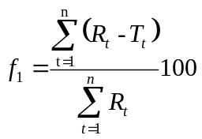 | (11.9)
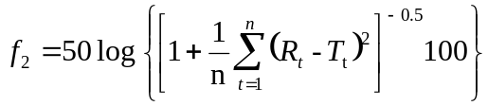 | (11.10)
where
n = number of dissolution time points
R_{t} = dissolution value of the reference drug product at time t
T_{t} = dissolution value of the test drug product at time t
The guidelines adopted for interpreting f₁ and f₂ values are given in table 11.4.

Table 11.4.
Comparison of Dissolution Profile
Difference factor f₁ | Similarity factor f2 | Inference
0 | 100 | Dissolution profiles are identical
≤ 15 | ≥ 50 | Similarity or equivalence of two profiles

The evaluation of similarity between dissolution profiles is based on following conditions –
- Minimum of three dissolution time points are measured.
- Number of drug products tested for dissolution is 12 for both test and reference.
- Not more than one mean value of > 85% dissolved for each product.
- Standard deviation of mean of any product should not be more than 10% from second to last dissolution time point.

In Vitro—In Vivo Correlation (IVIVC)
A simple in vitro dissolution test on the drug product will be insufficient to predict its therapeutic efficacy. Convincing correlation between in vitro dissolution behaviour of a drug and its in vivo bioavailability must be experimentally demonstrated to guarantee reproducibility of biologic response. In vitro-in vivo correlation is defined as the predictive mathematical model that describes the relationship between an in-vitro property (such as the rate and extent of dissolution) of a dosage form and an in-vivo response (such as the plasma drug concentration or amount of drug absorbed).

The main objective of developing and evaluating an IVIVC is to enable the dissolution test to serve as a surrogate (alternate) for in vivo bioavailability studies in human beings.
The applications of developing such an IVIVC are —
- To ensure batch-to-batch consistency in the physiological performance of a drug product by use of such in vitro values.
- To serve as a tool in the development of a new dosage form with desired in vivo performance.
- To assist in validating or setting dissolution specifications (i.e. the dissolution specifications are based on the performance of product in vivo).
There are two basic approaches by which a correlation between dissolution testing and bioavailability can be developed:
- By establishing a relationship, usually linear, between the in vitro dissolution and the in vivo bioavailability parameters.
- By using the data from previous bioavailability studies to modify the dissolution methodology in order to arrive at meaningful in vitro-in vivo correlation.
Though the former approach is widely used, the latter still holds substance, since to date, there is no single dissolution rate test methodology that can be applied to all drugs.
Some of the often used quantitative linear in vitro-in vivo correlations are –
- Correlations Based on the Plasma Level Data: Here linear relationships between dissolution parameters such as percent drug dissolved, rate of dissolution, rate constant for dissolution, etc. and parameters obtained from plasma level data such as percent drug absorbed, rate of absorption, Cmax, tmax, Ka, etc. are developed; for example, percent drug dissolved versus percent drug absorbed plots.
- Correlation Based on the Urinary Excretion Data: Here, dissolution parameters are correlated to the amount of drug excreted unchanged in the urine, cumulative amount of drug excreted as a function of time, etc.
- Correlation Based on the Pharmacological Response: An acute pharmacological effect such as LD50 in animals is related to any of the dissolution parameters.
Statistical moments theory can also be used to determine the relationship such as mean dissolution time (in vitro) versus mean residence time (in vivo).
Though examples of good correlations are many, there are instances when positive correlation is difficult or impossible; for example, in case of corticosteroids, the systemic availability may not depend upon the dissolution characteristics of the drug. Several factors that limit such a correlation include variables pertaining to the drug such as dissolution methodology, physicochemical properties of the drug such as particle size, physiologic variables like presystemic metabolism, etc.
In vitro-In vivo Correlation Levels
Three IVIVC levels have been defined and categorised in descending order of usefulness.
Level A – The highest category of correlation, it represents a point-to-point relationship between in vitro dissolution and the in vivo rate of absorption (or in vivo dissolution) i.e. the in vitro dissolution and in vivo absorption rate curves are superimposable and the mathematical description for both curves is the same.
Advantages of level A correlation are as follows –
- A point-to-point correlation is developed. The in vitro dissolution curve serves as a surrogate for in vivo performance. Any change in manufacturing procedure or modification in formula can be justified without the need for additional human studies.
- The in vivo dissolution serves as in vivo indicating quality control procedure for predicting dosage form’s performance.
Level B – Utilises the principles of statistical moment analysis. The mean in vitro dissolution time is compared to either the mean residence time or the mean in vivo dissolution time. However, such a correlation is not a point-to-point correlation since there are a number of in vivo curves that will produce similar mean residence time values. It is for this reason that one cannot rely upon level B correlation to justify changes in manufacturing or modification in formula. Moreover, the in vitro data cannot be used for quality control standards.
Level C – It is a single point correlation. It relates one dissolution time point (e.g. t_{50%}, etc.) to one pharmacokinetic parameter such as AUC, t_{max} or C_{max}. This level is generally useful only as a guide in formulation development or quality control owing to its obvious limitations.
Multiple Level C – It is correlation involving one or several pharmacokinetic parameters to the amount of drug dissolved at various time points.
Biopharmaceutics Classification System (BCS) and In vitro-In vivo Correlation (IVIVC)
The Biopharmaceutics Classification System (BCS) is a fundamental guideline for determining the conditions under which in-vitro in-vivo correlations are expected. Table 11.5 indicates whether IVIVC is expected or possible for various drug categories when formulated as controlled-release preparations. The importance of BCS in formulation design and drug delivery is further highlighted in table 11.8.
Table 11.5.

Biopharmaceutics Drug Classification System for Extended Release Drug Products
Class | Solubility | Permeability | IVIVC
Ia | High and site independent | High and site independent | IVIVC Level A expected
Ib | High and site independent | Dependent on site and narrow absorption window | IVIVC Level C expected
IIa | Low and site independent | High and site independent | IVIVC Level A expected
IIb | Low and site independent | Dependent on site and narrow absorption window | Little or no IVIVC
Va: Acidic | Variable | Variable | Little or no IVIVC
Vb: basic | Variable | Variable | IVIVC Level A expected

BCS-Based Biowaiver to In Vivo Bioavailability/Bioequivalence Studies
According to BCS, in vivo bioavailability and bioequivalence studies need not be conducted for drug products under following circumstances -
- Rapid and similar dissolution.
- High solubility.
- High permeability.
- Wide therapeutic window.
- Excipients used in dosage form are same as those present in approved drug product.
BIOEQUIVALENCE STUDIES
Need/Objectives for Biequivalence Studies
If a new product is intended to be a substitute for an approved medicinal product as a pharmaceutical equivalent or alternative, the equivalence with this product should be shown or justified. In order to ensure clinical performance of such drug products, bioequivalence studies should be performed. Bioequivalence studies are conducted if there is:
- A risk of bio-inequivalence and/or
- A risk of pharmacotherapeutic failure or diminished clinical safety.

Some of the important terms relevant in this context will be defined.
Equivalence: It is a relative term that compares drug products with respect to a specific characteristic or function or to a defined set of standards. There are several types of equivalences.
Chemical Equivalence: It indicates that two or more drug products contain the same labelled chemical substance as an active ingredient in the same amount.
Pharmaceutical Equivalence: This term implies that two or more drug products are identical in strength, quality, purity, content uniformity and disintegration and dissolution characteristics; they may however differ in containing different excipients.
Bioequivalence: It is a relative term which denotes that the drug substance in two or more identical dosage forms, reaches the systemic circulation at the same relative rate and to the same relative extent i.e. their plasma concentration-time profiles will be identical without significant statistical differences.
When statistically significant differences are observed in the bioavailability of two or more drug products, bio-inequivalence is indicated.
Therapeutic Equivalence: This term indicates that two or more drug products that contain the same therapeutically active ingredient elicit identical pharmacological effects and can control the disease to the same extent.

Types of Bioequivalence Studies
Bioequivalence can be demonstrated either –
- In vivo, or
- In vitro.
In vivo Bioequivalence Studies
The following sequence of criteria is useful in assessing the need for in vivo studies:
1. Oral immediate release products with systemic action
- Indicated for serious conditions requiring assured response
- Narrow therapeutic margin
- Pharmacokinetics complicated by absorption < 70% or absorption window, nonlinear kinetics, presystemic elimination > 70%
- Unfavourable physiochemical properties, e.g. low solubility, metastable modifications, instability, etc.
- Documented evidence for bioavailability problems
- No relevant data available, unless justification by applicant that in vivo study is not necessary.
2. Non-oral immediate release products.
3. Modified release products with systemic action.

In vivo bioequivalence studies are conducted in the usual manner as discussed for bioavailability studies, i.e. the pharmacokinetic and the pharmacodynamic methods.

In vitro Bioequivalence Studies
If none of the above criteria is applicable, comparative in vitro dissolution studies will suffice. In vitro studies, i.e. dissolution studies can be used in lieu of in vivo bioequivalence under certain circumstances, called as biowaivers (exemptions) –
      - The drug product differs only in strength of the active substance it contains, provided all the following conditions hold –
- Pharmacokinetics are linear
- The qualitative composition is the same
- The ratio between active substance and the excipients is the same, or (in the case of small strengths) the ratio between the excipients is the same
- Both products are produced by the same manufacturer at the same production site
- A bioavailability or bioequivalence study has been performed with the original product
- Under the same test conditions, the in vitro dissolution rate is the same.
      - The drug product has been slightly reformulated or the manufacturing method has been slightly modified by the original manufacturer in ways that can convincingly be argued to be irrelevant for the bioavailability.
      - The drug product meets all of the following requirements –
- The product is in the form of solution or solubilised form (elixir, syrup, tincture, etc.)
- The product contains active ingredient in the same concentration as the approved drug product.
- The product contains no excipients known to significantly affect absorption of the active ingredient.
      - An acceptable IVIVC and the in vitro dissolution rate of the new product is equivalent with that of the already approved medicinal product.
Moreover,
- The product is intended for topical administration (cream, ointment, gel, etc.) for local effect.
- The product is for oral administration but not intended to be absorbed (antacid or radio-opaque medium).
- The product is administered by inhalation as a gas or vapour.
The criteria for drug products listed above indicate that bioavailability and bioequivalence are self-evident.

Bioequivalence Experimental Study Design
The various types of test designs that are usually employed in clinical trials, bioavailability and bioequivalence studies are discussed below.
1. Completely randomised designs
In a completely randomised design, all treatments (factor levels) are randomly allocated among all experimental subjects.
Method of randomisation
Label all subjects with the same number of digits, for e.g., if there are 20 subjects, number them from 1 to 20. Randomly select non-repeating random numbers (like simple randomisation) with among these labels for the first treatment, and then repeat for all other treatments.
Advantages
- The design is extremely easy to construct.
- It can accommodate any number of treatments and subjects.
- The design is easy and simple to analyse even though the sample sizes might not be the same for each treatment.
Disadvantages
- Although the design can be used for any number of treatments, it is best suited for situations in which there are relatively few treatments.
- All subjects must be as homogeneous as possible. Any extraneous sources of variability will tend to inflate the random error term, making it difficult to detect differences among the treatment (or factor level) mean responses.

2. Randomised block designs
First, subjects are sorted into homogeneous groups, called blocks and the treatments are then assigned at random within the blocks.
Method of Randomisation
Subjects having similar background characteristics are formed as blocks. Then treatments are randomised within each block, just like the simple randomisation. Randomisations for different blocks are done independent of each other.

Advantages
- With effective and systematic way of grouping, it can provide substantially more precise results than a completely randomised design of comparable size.
- It can accommodate any number of treatments or replications.
- Different treatments need not have equal sample size.
- The statistical analysis is relatively simple. The design is easy to construct.
- If an entire treatment or block needs to be dropped from the analysis for some reason, such as spoiled results, the analysis is not thereby complicated.
- Variability in experimental units can be deliberately introduced to widen the range of validity of the experimental results without sacrificing the precision of results.

Disadvantages
- Missing observations within a block require more complex analysis.
- The degrees of freedom of experimental error are not as large as with a completely randomised design.

3. Repeated measures, cross-over and carry-over designs
This is essentially a randomised block design in which the same subject serves as a block. The same subject is utilized for each of the treatments under study. Since we take repeated measures on each subject we get the design name “repeated measures design”. The study may involve several treatments or a single treatment evaluated at different points in time. The administration of two or more treatments one after the other in a specified or random order to the same group of patients is called a crossover design or change-over design. The drawback of crossover studies is the potential for distortion due to carry-over, that is, residual effects from preceding treatments. To prevent carry-over effects, one must always allow for a wash-out period during which most of the drug is eliminated from the body – generally about 10 elimination half-lives.
Example: clinical trials to monitor safety and side effects.
Method of Randomisation
Complete randomisation is used to randomise the order of treatments for each subject. Randomisations for different subjects are independent of each other.
Advantages
- They provide good precision for comparing treatments because all sources of variability between subjects are excluded from the experimental error.
- It is economic on subjects. This is particularly important when only a few subjects can be utilized for the experiments.
- When the interest is in the effects of a treatment over time, it is usually desirable to observe the same subject at different points in time rather than observing different subjects at the specified points in time.
Disadvantages
- There may be an order effect, which is connected with the position in the treatment order.
- There may be a carry-over effect, which is connected with the preceding treatment or treatments.

4. Latin square designs
Completely randomised design, randomised block design and repeated measures design are experiments where the person/subject/volunteer remains on the treatment from the start of the experiment until the end and thus are called as continuous trial. In a Latin square, however, each subject receives each treatment during the course of the experiment. A Latin square design is a two-factor design (subjects and treatments are the two factors) with one observation in each cell. Such a design is useful compared the earlier ones when three or more treatments are to be compared and carry-over effects are balanced. In a Latin square design, rows represent subjects, and columns represent treatments. A r x r Latin square design is a square with r rows and r columns such that each of the r2 cells contain one and only one of the r letters representing the treatments, and each letter appears once and only once in ever row and every column. A Latin square is called standard if the first row and the first column consist of the r letters in alphabetical order.
Randomised, balanced, cross-over Latin square design are commonly used for bioequivalence studies.

Advantages
- It minimizes the inter-subject variability in plasma drug levels.
- Minimizes the carry-over effects which could occur when a given dosage form influences the bioavailability of a subsequently administered product (intra-subject variability).
- Minimizes the variations due to time effect.
- Treatment effects can be studied from a small-scale experiment. This is particularly helpful in preliminary or pilot studies.
- Makes it possible to focus more on the formulation variables which is the key to success for any bioequivalence study.
Disadvantages
- The use of Latin square design will lead to a very small number of degrees of freedom for experimental error when only a few treatments are studied. On the other hand, when many treatments are studied, the degrees of freedom for experimental error maybe larger than necessary.
- The randomisation required is somewhat more complex than that for earlier designs considered.
- The study takes a long time since an appropriate washout period between two administrations is essential which may be very long if the drug has a long t½.
- When the number of formulations to be tested is more, the study becomes more difficult and subject dropout rates are also high. This can be overcome by use of a balanced incomplete block design in which a subject receives no more than 2 formulations.
An example of a typical Latin square design is given in table 11.6.
Table 11.6.
Latin Square Cross-over Design for 6 (or 12) Subjects to
Compare Three Different Formulations, A, B and C
Subject number | Study period I | Washout period | Study period II | Washout period | Study period III
1, 7 | A |  | B |  | C
2, 8 | B |  | C |  | A
3, 9 | C |  | A |  | B
4, 10 | A |  | C |  | B
5, 11 | C |  | B |  | A
6, 12 | B |  | A |  | C

Bioequivalence Study Protocol
The elements of in vivo bioequivalence study protocol are listed in table 11.7.
Table 11.7.
Elements of Bioequivalence Study Protocol
1. | Title | c. | Inclusion/exclusion criteria
a. | Principal investigator |  | i. Inclusion criteria
b. | Project number and date |  | ii. Exclusion criteria
2. | Study objective | d. | Restrictions/prohibitions
3. | Study design | 5. | Clinical procedures
a. | Design | a. | Dosage and drug administration
b. | Drug Products | b. | Biological sampling schedule
 | i. Test product(s) | c. | Activity of subjects
 | ii. Reference product | 6. | Ethical considerations
c. | Dosage regimen | a. | Basic principles
d. | Sample collection schedule | b. | Institutional review board
e. | Housing | c. | Informed consent
f. | Fasting/meals schedule | d. | Indications for subject withdrawal
g. | Analytical methods | e. | Adverse reactions and emergency procedures
4. | Study population | 7. | Facilities
a. | Subjects | 8. | Data analysis
b. | Subject selection | a. | Analytical validation procedure
 | i. Medical history | b. | Statistical treatment of data
 | ii. Physical examination | 9. | Drug accountability
 | iii. Laboratory tests | 10. | Appendix

The in vivo bioequivalence study requires determination of relative bioavailability after administration of a single dose of test and reference formulations by the same route, in equal doses, but at different times. The reference product is generally a previously approved product, usually the innovator’s product or some suitable reference standard. The study is performed in fasting, young, healthy, adult male volunteers to assure homogeneity in the population and to spare the patients, elderly or pregnant women from rigors of such a clinical investigation. Homogeneity in the study population permits focus on formulation factors.
As for bioavailability studies, either plasma level or urinary excretion studies may be performed to assess bioequivalence between drug products. In vitro-in vivo correlation can also be established for the formulations.
It is always easier to establish bioequivalence between existing drug products than determination of pharmacokinetics of a new drug or bioavailability of a new dosage form since —
- The human volunteers used for the study of both products are same and all pharmacokinetic parameters can be assumed to be same for both drug formulations and there is no need to investigate nonlinearity.
- The study protocol for all subjects is uniform, the efficiency of drug absorption from both formulations can be considered as same and thus differences in absorption pattern can be ascribed to differences in drug release from the two dosage form.
Statistical Interpretation of Bioequivalence Data
After the data has been collected, statistical methods must be applied to determine the level of significance of any observed difference in the rate and/or extent of absorption in order to establish bioequivalence between two or more drug products. The commonly adopted approaches to determine statistical differences are -
- Analysis of variance (ANOVA) is a statistical procedure used to test the data for differences within and between treatment and control groups. A statistical difference between the pharmacokinetic parameters obtained from two or more drug products is considered statistically significant if there is a probability of less than 1 in 20 or 0.05 (p ≤ 0.05). The probability p is used to indicate the level of statistical significance. If p ≤ 0.05, the differences between the two drug products are not considered statistically significant.
- Confidence interval approach – Also called as two one-sided test procedure, it is used to demonstrate if the bioavailability from the test product is too low or high in comparison to the reference product. The 90% confidence limits are estimated for the sample means based on Student’s t distribution of data. A 90% confidence interval about the ratio of means of the two drug products must be within ± 20% for bioavailability parameters such AUC or C_{max} i.e. the difference between the bioavailabilities of the test product should not be greater than ± 20% of the average of reference product (between 80 and 120%). When log transformed data are used, the 90% confidence interval is set at 80-125%. These confidence limits are also termed as bioequivalence interval.

METHODS FOR ENHANCEMENT OF BIOAVAILABILITY
As far as the definition of bioavailability is concerned, a drug with poor bioavailability is the one with -
- Poor aqueous solubility and/or slow dissolution rate in biological fluids.
- Poor permeability through the biomembrane owing to inadequate partition coefficient or lipophilicity or large molecular size such as that of protein or peptide drugs such as insulin.
Both solubility as well as permeability of a drug depends upon its physicochemical characteristics as discussed in Chapter 2.
Based on the intestinal permeability and solubility of drugs, Amidon et al developed Biopharmaceutics Classification System (BCS) which classifies the drugs into one of the 4 groups as shown in the table 11.8. The table also shows the approaches employed to overcome formulation challenges in each class of drugs.

TABLE 11.8.

The Biopharmaceutics Classification System for Drugs
Class | Solubility | Permeability | Absorption Pattern | Examples | Challenges in Drug Delivery
I | High | High | Well absorbed | Diltiazem  Propranolol  Metoprolol | No major challenges for immediate release forms but CR forms need to limit drug release or dissolution since absorption of released drug is rapid.
II | Low | High | Variable | Nifedipine  Carbamazepine  Naproxen | Formulations are designed to overcome solubility or dissolution problems by various means (see later sections of this chapter).
III | High | Low | Variable | Insulin  Metformin  Cimetidine | Approaches are employed to enhance permeability (see later sections of this chapter).
IV | Low | Low | Poorly absorbed | Taxol  Chlorthiazide  Furosemide | Combination of strategies used for Class II and Class III drugs are employed to improve both dissolution and permeability.
Class V drugs: are those that are metabolically or chemically unstable thus limiting their bioavailability. The various approaches to overcome these problems are aimed at enhancing their stability by use of methods such as –
- Prodrug design.
- Enteric coating (protection from stomach acid).
- Enzyme inhibition or lymphatic delivery (to prevent presystemic metabolism).
- Lipid technologies.
Class I drugs (high solubility/high permeability) are well absorbed orally since they have neither solubility nor permeability limitation.
Class II drugs (low solubility/high permeability) show variable absorption owing to solubility limitation.
Class III drugs (high solubility/low permeability) also show variable absorption owing to permeability limitation.
Class IV drugs (low solubility/low permeability) are poorly absorbed orally owing to both solubility and permeability limitations.
Class V drugs – are the ones that do not come under the purview of BCS classification but includes drugs whose absorption is limited owing to their poor stability in GI milieu –
- Gastric instability (omeprazole).
- Complexation in GI lumen.
- First pass metabolism – by intestinal enzymes (peptide drugs), hepatic enzymes, microbial enzymes, etc.

The BCS classification of a drug depends upon its three key parameters that control absorption – solubility, dissolution rate and permeability that correlates with three respective dimensionless parameters – dose number, dissolution number and absorption number (see table 11.9 and figure 11.4).

TABLE 11.9.

Drug Properties that Determine BCS Classification
Drug property influencing absorption | Corresponding Dimensionless parameter | Significance
Solubility: A drug with high solubility is the one whose largest dosage strength is soluble in 250 ml or less of water over a pH range of 1-8. | Dose number: It is the mass of drug divided by an uptake volume of 250 ml and the drug’s solubility. | Ideally, dose ratio should be below 1 if full dissolution is to be possible in principle. Obviously, higher doses will raise the ratio and absorption less likely.
Dissolution rate: A drug product with rapid dissolution is the one when > 85% of the labelled amount of drug substance dissolves within 30 minutes using USP apparatus I or II in a volume of < 900 ml buffer solutions. | Dissolution number: It is the ratio of mean residence time to mean dissolution time. | Ideally, dissolution number should exceed 1. In the case of solid dosage forms, a combination of inadequate solubility or diffusivity, or excessive particle size or density can increase the time needed for full dissolution and reduce this ratio.
Permeability: A drug with high permeability is the one having extent of absorption greater than 90% of the administered dose given that the drug is stable in the gastrointestinal environment | Absorption number: It is the ratio of the mean residence time of drug in the GIT to the absorption time. | Ideally, absorption number should exceed 1. Longer absorption times resulting from lower permeability will reduce this ratio.

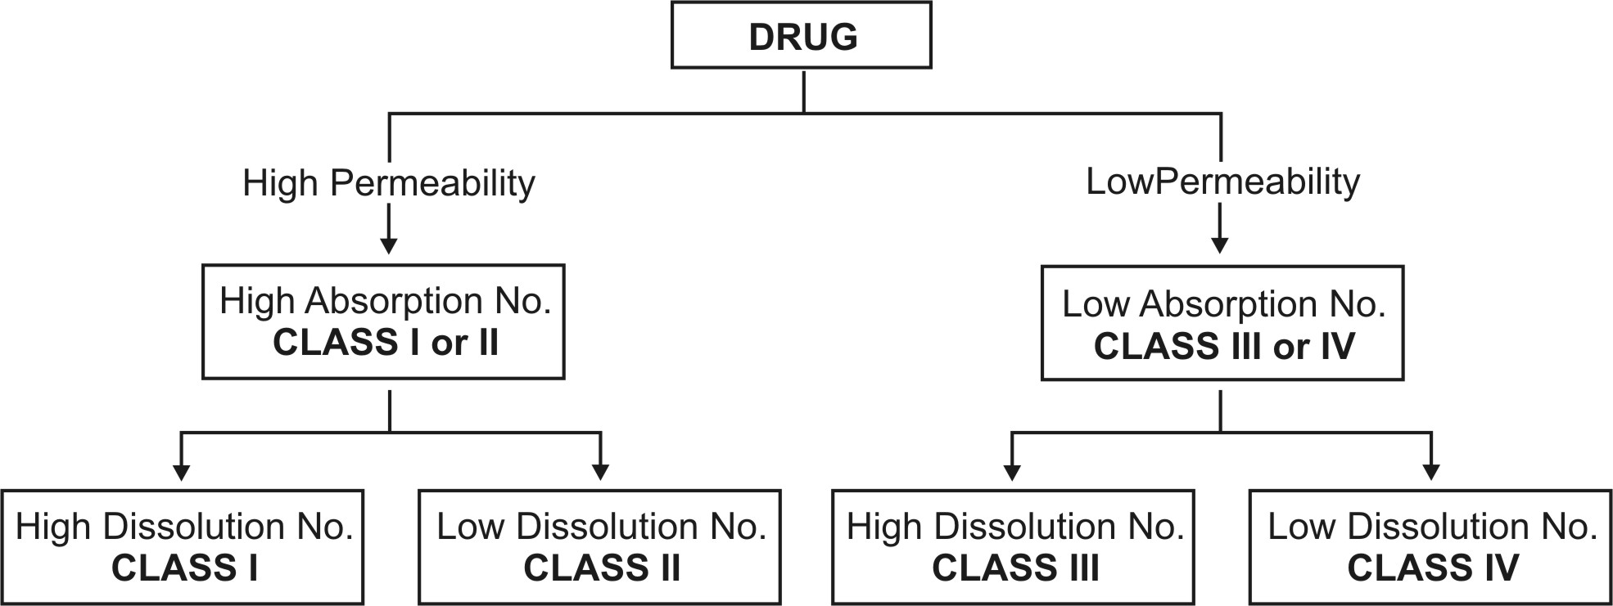
Fig. 11.4 Classification of Drugs on BCS basis

Solubility Determination – Methods for determining drug solubility are –
- pH-solubility profile of test drug in aqueous media with a pH range of 1 to 7.5.
- Shake-flask or titration method.

Permeability Determination – The methods are further classified as –
Determination of extent of absorption in humans:
    - Mass-balance pharmacokinetic studies.
    - Absolute bioavailability studies.
Intestinal permeability methods:
    - In vivo intestinal perfusions studies in humans.
    - In vivo or in situ intestinal perfusion studies in animals.
    - In vitro permeation experiments with excised human or animal intestinal tissue.
    - In vitro permeation experiments across epithelial cell monolayers.

Dissolution Determination – Methods for determining drug product dissolution are –
USP apparatus I (basket) at 100 rpm or USP apparatus II (paddle) at 50 rpm.
Dissolution media (900 ml): 0.1 N HCl or simulated gastric fluid, pH 4.5 buffer, and pH 6.8 buffer or simulated intestinal fluid.
Compare dissolution profiles of test and reference products using a similarity factor (f₂).

Besides identifying the challenges in formulation design, the BCS is designed to guide decisions with respect to in vitro and in vivo correlations (IVIVC).
The three conceptual approaches in overcoming the bioavailability problems of drugs are:
            - The Pharmaceutical Approach which involves modification of formulation, manufacturing process or the physicochemical properties of the drug without changing the chemical structure.
            - The Pharmacokinetic Approach in which the pharmacokinetics of the drug is altered by modifying its chemical structure. This approach is further divided into two categories –
- Development of new chemical entity (NCE) with desirable features
- Prodrug design.
- The Biological Approach whereby the route of drug administration may be changed such as changing from oral to parenteral route.
The second approach of chemical structure modification has a number of drawbacks of being very expensive and time consuming, requires repetition of clinical studies and a long time for regulatory approval. Moreover, the new chemical entity may suffer from another pharmacokinetic disorder or bear the risk of precipitating adverse effects. Only the pharmaceutical approach will be dealt herewith.
The pharmaceutical attempts, whether optimising the formulation, manufacturing process or physicochemical properties of the drug, are mainly aimed at altering the biopharmaceutic properties of drug in one of the several ways –
- Enhancement of drug solubility or dissolution rate, as it is the major rate-limiting step in the absorption of most drugs. This approach applies to class II drugs according to BCS.
- Enhancement of drug permeability. This approach applies to class III drugs according to BCS.
- Enhancement of drug stability. This approach applies to class V drugs according to BCS.
- Enhancement of gastrointestinal retention. This approach can apply to class II, III or V drugs.

BIOAVAILABILITY ENHANCEMENT THROUGH ENHANCEMENT OF DRUG SOLUBILITY OR DISSOLUTION RATE
There are several ways by which drug solubility or the dissolution rate can be enhanced. Some of the widely used methods are discussed briefly.
1. Micronization: The process involves reducing the size of the solid drug particles to 1 to 10 microns commonly by spray drying or by use of air attrition methods (fluid energy or jet mill). The process is also called as micro-milling. Examples of drugs whose bioavailability have been increased by micronization include griseofulvin and several steroidal and sulpha drugs.

2. Nanonisation: It’s a process whereby the drug powder is converted to nanocrystals of sizes 200 - 600 nm, e.g. amphotericin B. The main production technologies currently in use to produce drug nanocrystals yield as a product a dispersion of drug nanocrystals in a liquid, typically water (called nanosuspension). There are three basic technologies currently in use to prepare nanoparticles:
- Pearl milling
- Homogenisation in water (wet milling as in a colloid mill)
- Homogenisation in non-aqueous media or in water with water-miscible liquids.

3. Supercritical Fluid Recrystallization: Another novel nanosizing and solubilisation technology whose application has increased in recent years is particle size reduction via supercritical fluid (SCF) processes. Supercritical fluids (e.g. carbon dioxide) are fluids whose temperature and pressure are greater than its critical temperature (Tc) and critical pressure (Tp), allowing it to assume the properties of both a liquid and a gas. At near-critical temperatures, SCFs are high compressible, allowing moderate changes in pressure to greatly alter the density and mass transport characteristics of a fluid that largely determine its solvent power. Once the drug particles are solubilised within SCF, they may be recrystallised at greatly reduced particle sizes.

4. Use of Surfactants: Surfactants are very useful as absorption enhancers and enhance both dissolution rate as well as permeability of drug. They enhance dissolution rate primarily by promoting wetting and penetration of dissolution fluid into the solid drug particles. They are generally used in concentration below their critical micelle concentration (CMC) values since above CMC, the drug entrapped in the micelle structure fails to partition in the dissolution fluid. Nonionic surfactants like polysorbates are widely used. Examples of drugs whose bioavailability have been increased by use of surfactants in the formulation include steroids like spironolactone.
5. Use of Salt Forms: Salts have improved solubility and dissolution characteristics in comparison to the original drug. It is generally accepted that a minimum difference of 3 units between the pKa value of the group and that of its counterion is required to form stable salts. Alkali metal salts of acidic drugs like penicillins and strong acid salts of basic drugs like atropine are more water-soluble than the parent drug. Factors that influence salt selection are physical and chemical properties of the salt, safety of counterion, therapeutic indications and route of administration.
Salt formation does have its limitations –
- It is not feasible to form salts of neutral compounds.
- It may be difficult to form salts of very weak bases or acids.
- The salt may be hygroscopic, exhibit polymorphism or has poor processing characteristics.
- Conversion of salt to free acid or base form of the drug on surface of solid dosage form that prevents or retards drug release.
- Precipitation of unionised drug in the GI milieu that has poor solubility.
6. Use of Precipitation Inhibitors: A significant increase in free drug concentration above equilibrium solubility results in supersaturation, which can lead to drug precipitation or crystallization. This can be prevented by use of inert polymers such HPMC, PVP, PVA, PEG, etc. which act by one or more of the following mechanisms -
- Increase the viscosity of crystallization medium thereby reducing the crystallization rate of drugs.
- Provide a steric barrier to drug molecules and inhibit crystallization through specific intermolecular interactions on growing crystal surfaces.
- Adsorb onto faces of host crystals, reduce the crystal growth rate of the host and produce smaller crystals.
7. Alteration of pH of the Drug Microenvironment: This can be achieved in two ways—in situ salt formation, and addition of buffers to the formulation e.g. buffered aspirin tablets.
8. Use of Amorphs, Anhydrates, Solvates and Metastable Polymorphs: Depending upon the internal structure of the solid drug, selection of proper form of drug with greater solubility is important. In general, amorphs are more soluble than metastable polymorphs, anhydrates are more soluble than hydrates and solvates are more soluble than non-solvates.
9. Solvent Deposition: In this method, the poorly aqueous soluble drug such as nifedipine is dissolved in an organic solvent like alcohol and deposited on an inert, hydrophilic, solid matrix such as starch or microcrystalline cellulose by evaporation of solvent.
10. Precipitation: In this method, the poorly aqueous soluble drug such as cyclosporine is dissolved in a suitable organic solvent followed by its rapid mixing with a non-solvent to effect precipitation of drug in nanosize particles. The product so prepared is also called as hydrosol.
11. Selective Adsorption on Insoluble Carriers: A highly active adsorbent such as the inorganic clays like bentonite can enhance the dissolution rate of poorly water-soluble drugs such as griseofulvin, indomethacin and prednisone by maintaining the concentration gradient at its maximum. The two reasons suggested for the rapid release of drugs from the surface of clays are—the weak physical bonding between the adsorbate and the adsorbent, and hydration and swelling of the clay in the aqueous media.
12. Solid Solutions: The three means by which the particle size of a drug can be reduced to submicron level are—
- Use of solid solutions,
- Use of eutectic mixtures, and
- Use of solid dispersions.
In all these cases, the solute is frequently a poorly water-soluble drug acting as the guest and the solvent is a highly water-soluble compound or polymer acting as a host or carrier.
A solid solution is a binary system comprising of a solid solute molecularly dispersed in a solid solvent. Since the two components crystallize together in a homogeneous one phase system, solid solutions are also called as molecular dispersions or mixed crystals. Because of reduction in particle size to the molecular level, solid solutions show greater aqueous solubility and faster dissolution than eutectics and solid dispersions. They are generally prepared by fusion method whereby a physical mixture of solute and solvent are melted together followed by rapid solidification. Such systems, prepared by fusion, are often called as melts e.g. griseofulvin-succinic acid (Fig. 11.5). The griseofulvin from such solid solution dissolves 6 to 7 times faster than pure griseofulvin.
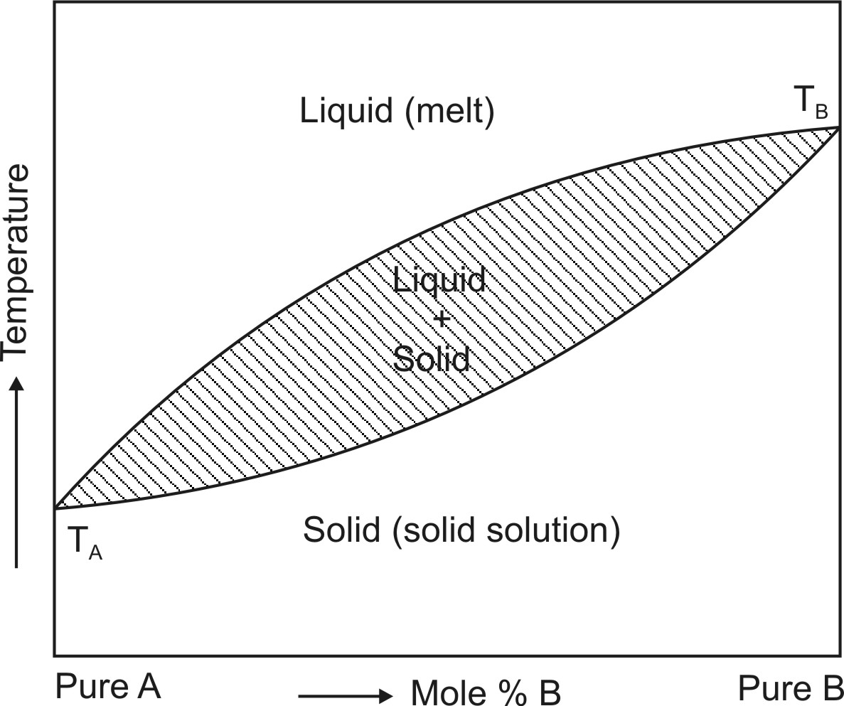
Fig. 11.5 Binary phase diagram for continuous solid solution of A and B. TA and TB are melting points of pure A and pure B respectively.
If the diameter of solute molecules is less than 60% of diameter of solvent molecules or its volume less than 20% of volume of solvent molecule, the solute molecule can be accommodated within the intermolecular spaces of solvent molecules e.g. digitoxin-PEG 6000 solid solution. Such systems show faster dissolution. When the resultant solid solution is a homogeneous transparent and brittle system, it is called as glass solution. Carriers that form glassy structure are citric acid, urea, PVP and PEG and sugars such as dextrose, sucrose and galactose.
Solid solutions can be classified on two basis –
    - Miscibility between the drug and the carrier – on this basis the solid solutions are divided into two categories –
      - Continuous solid solution is the one in which both the drug and the carrier are miscible in all proportions. Such a solid solution is not reported in pharmaceutical literature.
      - Discontinuous solid solution is the one where solubility of each of the component in the other is limited (see fig. 11.5).
    - Distribution of drug in carrier structure – on this basis the solid solutions are divided into two categories –
      - Substitutional crystalline solid solution is the one in which the drug molecules substitute for the carrier molecules in its crystal lattice. This happens when the drug and carrier molecules are almost of same size.
      - Interstitial crystalline solid solution is the one in which the drug molecules occupy the interstitial spaces in the crystal lattice of carrier molecules. This happens when the size of drug molecule is 40% or less than the size of carrier molecules (fig. 11.6).
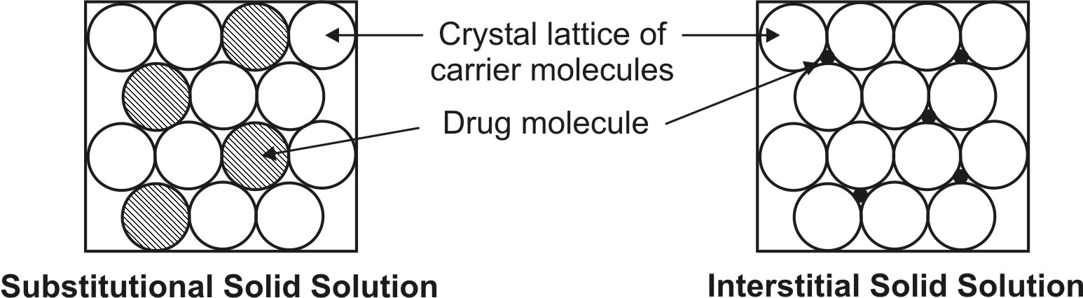
Fig. 11.6 Types of crystalline solid solution
The two mechanisms suggested for enhanced solubility and rapid dissolution of molecular dispersions are:
- When the binary mixture is exposed to water, the soluble carrier dissolves rapidly leaving the insoluble drug in a state of microcrystalline dispersion of very fine particles, and
- When the solid solution, which is said to be in a state of randomly arranged solute and solvent molecules in the crystal lattice, is exposed to the dissolution fluid, the soluble carrier dissolves rapidly leaving the insoluble drug stranded at almost molecular level.
Fig. 11.7 shows a comparison between the dissolution rates of different forms of griseofulvin.
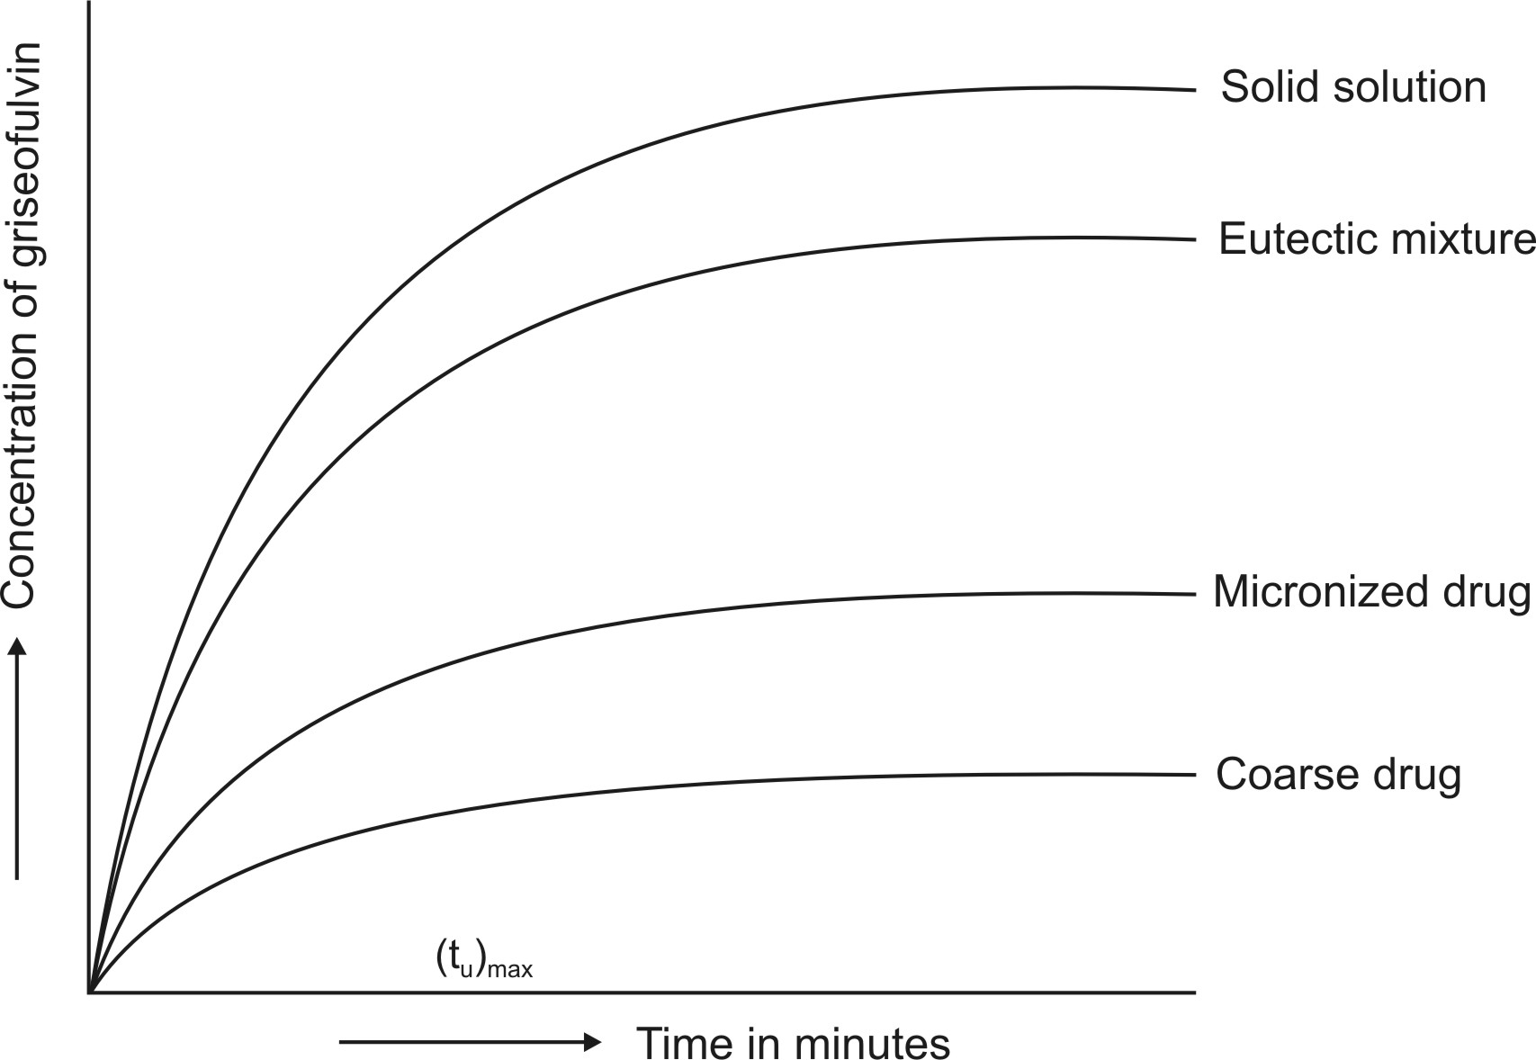
Fig. 11.7 Dissolution rates of griseofulvin as coarse particles, as micronized particles and as eutectic and solid solution with succinic acid.
13. Eutectic Mixtures: These systems are also prepared by fusion method. Eutectic melts differ from solid solutions in that the fused melt of solute-solvent show complete miscibility but negligible solid-solid solubility i.e. such systems are basically intimately blended physical mixture of two crystalline components. A phase diagram of two-component system is shown in Fig. 11.8. When the eutectic mixture is exposed to water, the soluble carrier dissolves leaving the drug in a microcrystalline state which solubilises rapidly.
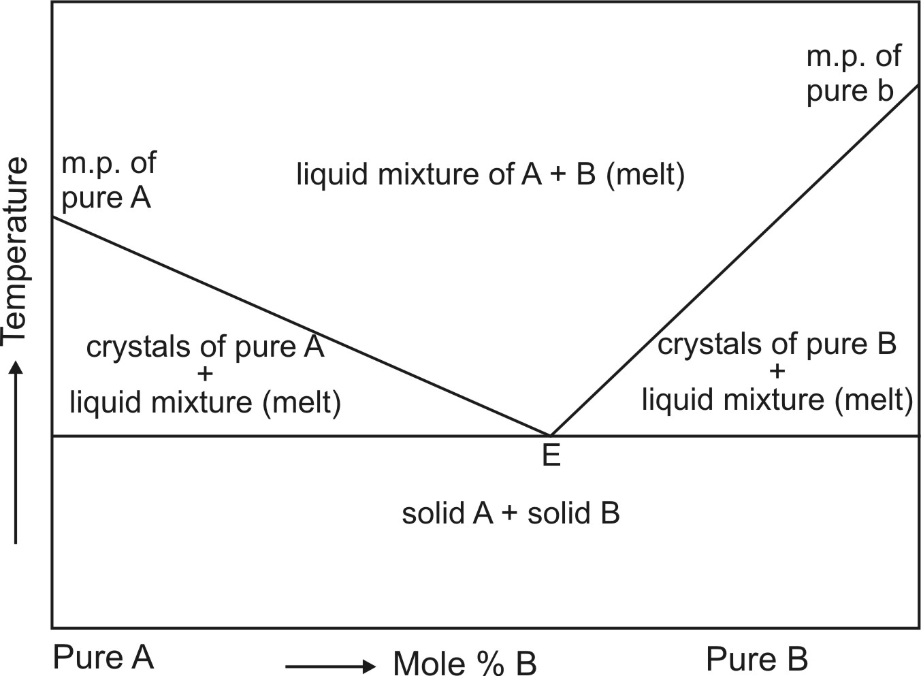
Fig. 11.8 Simple binary phase diagram showing eutectic point E. The eutectic composition at point E of substances A and B represents the one having lowest melting point.
Examples of eutectics include paracetamol-urea, griseofulvin-urea, griseofulvin-succinic acid, etc. Solid solutions and eutectics, which are basically melts, are easy to prepare and economical with no solvents involved. The method, however, cannot be applied to:
- Drugs which fail to crystallize from the mixed melt.
- Drugs which are thermolabile.
- Carriers such as succinic acid that decompose at their melting point. The eutectic product is often tacky, intractable or irregular crystal.
14. Solid Dispersions: These are generally prepared by solvent or co-precipitation method whereby both the guest solute and the solid carrier solvent are dissolved in a common volatile liquid solvent such as alcohol. The liquid solvent is removed by evaporation under reduced pressure or by freeze-drying which results in amorphous precipitation of guest in a crystalline carrier. Thus, the basic difference between solid dispersions and solid solutions/eutectics is that the drug is precipitated out in an amorphous form in the former as opposed to crystalline form in the latter; e.g. amorphous sulphathiazole in crystalline urea. Such dispersions are often called as co-evaporates or co-precipitates. The method is suitable for thermolabile substances but has a number of disadvantages like higher cost of processing, use of large quantities of solvent, difficulty in complete removal of solvent, etc. The carriers used are same as for eutectics or solid solutions. With glassy materials, the dispersions formed are called as glass dispersions or glass suspensions. Fig. 11.9 shows comparative dissolution rates of griseofulvin from PVP dispersions. Other polymers such as PEG and HPMC are also employed to prepare solid dispersions of poorly water-soluble drugs such as nifedipine and itraconazole.
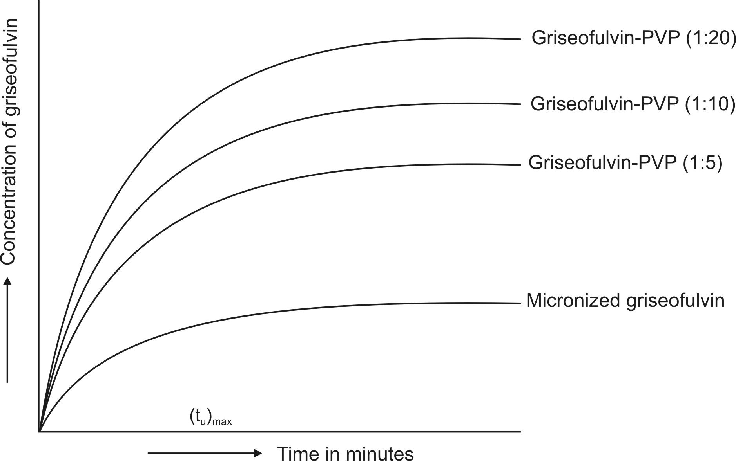
Fig. 11.9 Dissolution rate enhancement of griseofulvin by solid dispersion technique.

Preparation of solid dispersions also presents several limitations –
- Since the carrier is hydrophilic and the drug is hydrophobic, it is difficult to find a common solvent to dissolve both components.
- The product is often soft, waxy and possesses poor compressibility and flowability.
- Physical instability of the solid dispersion.
- Difficulty in preparation of a reproducible product.
15. Molecular Encapsulation with Cyclodextrins: The beta- and gamma-cyclodextrins and several of their derivatives are unique in having the ability to form molecular inclusion complexes with hydrophobic drugs having poor aqueous solubility. These bucket-shaped oligosaccharides produced from starch are versatile in having a hydrophobic cavity of size suitable enough to accommodate the lipophilic drugs as guests; the outside of the host molecule is relatively hydrophilic (Fig. 11.10). Thus, the molecularly encapsulated drug has greatly improved aqueous solubility and dissolution rate. There are several examples of drugs with improved bioavailability due to such a phenomenon — thiazide diuretics, barbiturates, benzodiazepines and a number of NSAIDs.
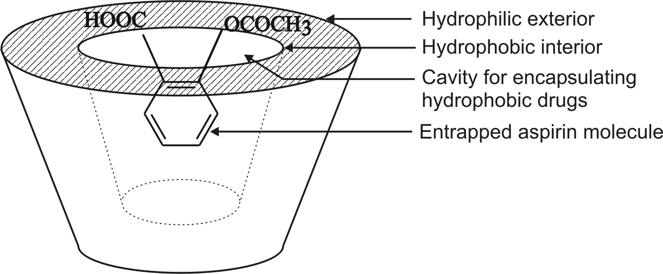
Fig. 11.10 Functional and structural feature of a cyclodextrin molecule showing an encapsulated drug.

16. Spherical Crystallization: add some text

BIOAVAILABILITY ENHANCEMENT THROUGH ENHANCEMENT OF DRUG PERMEABILITY ACROSS BIOMEMBRANE
On several occasions, the rate-limiting step in drug absorption is transport through the intestinal epithelium owing to poor permeability. Several approaches besides the use of lipophilic prodrugs that increase the drug permeation rate are discussed below.
1. Lipid Technologies: With an increase in the number of emerging hydrophobic drugs, several lipid-based formulations have been designed to improve their bioavailability by a combination of various mechanisms briefly summarized as follows:

- Physicochemical—Enhanced dissolution and solubility.
- Physiological—potential mechanisms include -
- Enhancement of effective luminal solubility by stimulation of secretion of bile salts, endogenous biliary lipids including phospholipids and cholesterol which together form mixed micelles and facilitate GI solubilization of drug.
- Reduction in gastric emptying rate thereby increasing the time available for dissolution and absorption.
- Increase in intestinal membrane permeability.
- Decreased intestinal blood flow.
- Decreased luminal degradation.
- Increased uptake from the intestinal lumen into the lymphatic system (and a reduction in first-pass hepatic and GI metabolism).
The various lipid-based dosage forms include – lipid solutions and suspensions, micelle solubilization, coarse emulsions, microemulsions, multiple emulsions, self-emulsifying drug delivery systems (SEDDS), self-microemulsifying drug delivery systems (SMEDDS), nanoparticles and liposomes.

The reasons for the increasing interest in lipid-based systems are due to the several advantages they offer and include:
- Physicochemical advantages: such as
- Solubilisation of drugs with low aqueous solubility
- Stabilisation of labile drugs against hydrolysis or oxidation.
- Pharmaceutical advantages: such as
- Better characterization of lipidic excipients
- Formulation versatility and the choice of different drug delivery systems
- Opportunity for formulation as sustained release product.
- Pharmacokinetic advantages: such as
- Improved understanding of the manner in which lipids enhance oral bioavailability
- Reduced plasma profile variability
- Potential for drug targeting applications.
- Pharmacodynamic advantages: such as
- Reduced toxicity
- Consistency in drug response.
  - Lipid solutions and suspensions: Some lipophilic drugs such as steroids have appreciable solubility in triacylglycerols alone. It is therefore comparatively straightforward to administer the drug in an oily liquid (e.g. encapsulated) and thereby achieve satisfactory absorption. One disadvantage of this formulation approach, however, is that oil alone rarely provides the solubilizing power to dissolve the required dose in a reasonable quantity of oil. This limits the option of using a simple drug/oil formulation system.
  - Coarse emulsions, microemulsions, SEDDS and SMEDDS: The ability of oil to accommodate a hydrophobic drug in solution can be improved by the addition of surfactants. The surfactants also perform the function of dispersing the liquid vehicle on dilution in gastrointestinal fluid. Hence, the drug is present in fine droplets of the oil/surfactants mixture which spread readily in the gastro-intestinal tract. Self-emulsifying/microemulsifying systems are formed using an oily vehicle (or a mixture of a hydrophilic phase and a lipophilic phase) a surfactant with a high HLB and if required, a co-surfactant. Unlike emulsions, the resultant liquid is almost clear. These pre-concentrates form spontaneously an emulsion/microemulsion in aqueous media (e.g. gastro-intestinal tract).
  - Solid lipid nanoparticles: To overcome the disadvantages associated with the liquid state of the oil droplets, the liquid lipid is replaced by a solid lipid leading to the formation of solid lipid nanoparticles. In contrast to emulsions, the particles consist of a solid core made from solid lipids. They are characterized by a mean diameter between approx. 100 to 1000 nm. There are two basic production techniques for solid lipid nanoparticles –
    - Homogenization of melted lipids at elevated temperature, and
    - Homogenization of a suspension of solid lipids at or below room temperature.
  - Liposomes: Liposomes are broadly defined as lipid bilayers surrounding an aqueous space. Liposoluble drugs can be embedded in the “fatty” regions, while hydrophilic substances are held in the aqueous internal spaces of these globular vesicles.

2. Ion Pairing: The ion pairing approach involves co-administration of a hydrophilic or polar drug with a suitable lipophilic counterion, which consequently improves the partitioning of the resultant ion-pair (relatively more lipophilic) into the intestinal membrane. In fact, the approach seems to increase the oral bioavailability of ionizable drugs, such as atenolol, by approximately 2-fold. However, it is important that a counterion possess high lipophilicity, sufficient aqueous solubility, physiological compatibility, and metabolic stability.
3. Penetration Enhancers: Compounds which facilitate the transport of drugs across the biomembrane are called as penetration/permeation enhancers or promoters. This method is used mainly in cases of hydrophilic drugs which are expected to have difficulty in penetrating the lipid structure of the biomembrane. Penetration enhancers act interaction of its lipid part with the polar component of membrane phospholipids.
Penetration enhancers can be divided into three categories –
- Substances that act very quickly have a strong effect and cause injury to the membrane (which is reversible), e.g. fatty acids such as oleic, linoleic and arachidonic and their monoglycerides.
- Substances that act quickly, cause temporary injury but have average activity, e.g. salicylates and certain bile salts.
- Substances having average to strong activity but cause sustained histological changes, e.g. SLS, EDTA and citric acid.

BIOAVAILABILITY ENHANCEMENT THROUGH ENHANCEMENT OF DRUG STABILITY
The various ways by which improvement of stability of drug in the GIT has a positive impact on bioavailability are discussed below.

1. Enteric Coating: Enteric-coated systems utilize polymeric coatings that are insoluble in the gastric media and therefore, prevent or retard drug release in the stomach. Such systems release the drug in the alkaline milieu of intestine. Bioavailability of drugs that are unstable in the gastric milieu, for e.g. erythromycin, penicillin V, pancreatin and benzimidizoles such as omeprazole can be improved by enteric coating.

2. Complexation: Complexation, in certain instances, can be used to increase the stability of drug in the GI milieu, particularly those of ester drugs and thus enhance their oral availability. Generally speaking, β-cyclodextrins are potential carriers for achieving such objectives but other complexing agents, such as caffeine, sodium salicylate, sodium benzoate, and nicotinamide, may also be used.

3. Use of Metabolism Inhibitors: Co-administration of a drug with low bioavailability and its metabolism inhibitor, which can selectively inhibit any of the contributing processes, would result in increased fractional absorption and hence a higher bioavailability. In fact, this approach seems to be a promising alternative to overcome the enzymatic barriers to oral delivery of metabolically labile drugs such as peptides and proteins. Current novel approaches in this area include:

- Bioadhesive delivery systems that can reduce the drug degradation between the delivery system and absorbing membrane by providing intimate contact with GI mucosa.
- Controlled-release microencapsulated systems that can provide simultaneous delivery of a drug and its specific enzyme inhibitor at the desired site for required period of time.
- Immobilization of enzyme inhibitors on mucoadhesive delivery systems.

Interestingly, the intestinal wall metabolism (prehepatic metabolism) may also be inhibited by co-administration of certain drugs and diet, which act by selectively inhibiting an enzyme present in enterocytes. An illustrative example is that of cyclosporin, which undergoes extensive intestinal metabolism, resulting in low bioavailability ranging between 30–40%. Studies have shown that co-administration of ketoconazole and grapefruit juice, which contains the inhibitory components, can significantly decrease the presystemic metabolism (both act via selective inhibition of intestinal, not hepatic, CYP3A4) and consequently increase the oral bioavailability of cyclosporin. In a differential manner, however, ketoconazole moderately inhibits P-gp, whereas grapefruit juice activates P-gp-mediated efflux of cyclosporine, which is a well-characterized substrate of P-gp, thereby partially counteracting the CYP3A4-inhibitory effects of grapefruit juice.
Grapefruit juice is reported to be a powerful inhibitor of enzyme CYP3A4 and is known to enhance the bioavailability of several drugs. It could be argued that extraction of such components from grapefruit juice (thought to be flavonoids) and their inclusion as excipient in the dosage form would lead to not only more complete but also more consistent systemic levels by counteracting inconsistencies brought about by enzyme inhibitors in food and drink.
Co-administration of a drug that can selectively inhibit an enzyme in the liver may lead to increased bioavailability of another drug. For example, co-administration of erythromycin can result in inhibition of hepatic metabolism and thereby significantly increase the oral bioavailability of cyclosporin. As a matter of fact, this attribute of erythromycin appears to be selective, which permits a noninvasive measurement of the in vivo hepatic CYP3A4 activity, popularly known as erythromycin breath test. Many examples also exist related to the inhibitory effects of diet on hepatic first-pass metabolism.

BIOAVAILABILITY ENHANCEMENT THROUGH GASTROINTESTINAL RETENTION
Gastro-retentive drug delivery systems (GRDDS) are designed on the basis of delayed gastric emptying and CR principles, and are intended to restrain and localize the drug delivery device in the stomach or within the upper parts of the small intestine until the entire drug is released. Excipients that are bioadhesive or that swell on hydration when incorporated in an oral dosage form, can promote gastro-retention and absorption by –
- Increased contact with epithelial surfaces
- Prolonging residence time in the stomach
- Delaying intestinal transit.
Cellulose ethers, gums of natural origin, and synthetic acrylic acid polymers have been evaluated for such purposes. The range of materials available and their differing viscoelastic and rheological behaviours mean that it is possible, by judicious admixture, to develop delivery units with balanced properties so that adhesion, density, hydration, drug release rate, etc. can be tailored to the drug in question and the physiological characteristics of the target delivery site.
QUESTIONs
- Define bioavailability. What are the objectives of bioavailability studies?
- Enumerate the factors affecting bioavailability of a drug from its dosage form.
- In a bioavailability study, explain how determination of both rate and extent of absorption are important.
- Define absolute and relative bioavailability. What is the basic difference between the two?
- What are the limitations of using oral solution as a standard for determining absolute bioavailability?
- Compare single dose with multiple dose bioavailability studies.
- Discuss the merits and demerits of using healthy subjects and patients as volunteers for bioavailability studies.
- What should be the duration of washout period between any two bioavailability studies in the same subject? Why?
- Name the methods for determining bioavailability of a drug from its dosage form.
- Which is the method of choice in bioavailability determination? On what principle is such a study based?
- Explain with significance the parameters used in bioavailability determination by plasma level studies.
- In multiple dose study, bioavailability determination is done at steady-state and one dosing interval. Explain.
- Why is determination of absorption rate not considered important in the multiple dosing method?
- What is the principle behind assessment of bioavailability using urinary excretion studies?
- Determination of metabolites in urine is not used as a measure of bioavailability? Why?
- Why should the volunteers be instructed to completely empty their bladders while giving urine samples?
- Why should frequent sampling of urine/plasma be done initially after drug administration in bioavailability determination?
- Name the parameters examined in urinary excretion data to determine bioavailability. What is their analogy with parameters of plasma level studies?
- What are the drawbacks of using acute pharmacological response and therapeutic response as measures of bioavailability?
- What is the reliable alternative to in vivo bioavailability studies in monitoring batch-to-batch consistency in pharmaceutical manufacturing?
- What factors should be considered in the design of dissolution testing models?
- What are the ideal features expected from dissolution apparatus?
- What are various compendial dissolution apparatus designs? Discuss briefly stating their applications.
- What is the importance of similarity factor f₂ in dissolution profile comparison?
- Define Q value. What is the dissolution acceptance criterion as per USP?
- What are the objectives and approaches in developing in vitro- in vivo correlation?
- Discuss the various methods of developing quantitative linear in vitro-in vivo relationships.
- What are various levels in in vitro-in vivo correlations?
- Discuss the significance of biopharmaceutic classification system in determining IVIVC?
- Define the terms ‘high solubility’ and high permeability’ according to BCS.
- What are various drug properties and their corresponding dimensionless parameters that form the basis of BCS classification?
- What criteria are necessary for BCS biowaiver for in vivo bioavailability/bioequivalence studies?
- Discuss the objectives for conductance of bioequivalence studies.
- Define the following — equivalence, chemical equivalence, pharmaceutical equivalence, bioequivalence and clinical equivalence.
- What are the various types of bioequivalence studies?
- Under what circumstances an in vivo bioequivalence studies need to be conducted?
- Why are bioequivalence studies always performed in healthy human volunteers?
- What are the circumstances for biowaiver of an in vivo bioequivalence study?
- Discuss with advantages and disadvantages the various methods of bioequivalence experimental study design.
- Draw a typical Latin square design for conducting bioequivalence study in 6 subjects for 3 three different formulations.
- Enlist the elements of a bioequivalence study protocol.
- Why is it easy to establish bioequivalence between dosage forms in comparison to determination of pharmacokinetics or bioavailability of a new formulation?
- What are the generally accepted, statistical rules for establishing bioequivalence between formulations?
- How are drugs classified according to biopharmaceutic classification system?
- What are the various approaches aimed at enhancing bioavailability of a drug from its dosage form?
- Discuss the methods aimed at enhancing bioavailability through enhancement of drug solubility or dissolution rate.
- Discuss the methods aimed at enhancing bioavailability through enhancement of drug permeability.
- Discuss the methods aimed at enhancing bioavailability through enhancement of drug stability.
- What are the various means by which the particle size of a drug can be reduced to submicron level?
- How are solid solutions classified?
- What is the basic difference between solid solutions and solid dispersions? Give reasons for the faster dissolution of the former.
- Solid solutions dissolve faster than eutectics. Why?
- Discuss the methods aimed at enhancing bioavailability through gastroretention.
- A new drug undergoes both degradation in gastric fluids as well as extensive presystemic hepatic metabolism. In order to obtain optimum oral bioavailability, which of the following formulations will you prefer: solution, suspension, tablet, enteric-coated tablet, SR tablet or enteric-coated microspheres? Why? Rank them in order of decreasing bioavailability.
- Following data is obtained for 4 formulations of pentoxifylline in volunteers of average weight 50 Kg.
Drug Product Dose (mg/kg) AUC (mcg.hr/l)
i.v. solution 1.2 450
oral solution 4.0 822
oral capsule 4.0 736
oral S.R. tablet 8.0 1040
a. What is the absolute bioavailability of the drug from capsule and SR tablet?
Answer : Capsule = 49% and SR tablet = 34.6%.
b. What is the relative bioavailability of capsule and SR tablet against oral solution?
Answer : Capsule = 89.5% and SR tablet = 63.2%.
c. Which solid formulation shows better bioavailability?
d. Are the two solid formulations bioequivalent?
e. What could be the possible reasons for poor bioavailability from SR tablets?
56. The three pharmacokinetic parameters from urinary excretion data of a drug given as 50 mg oral formulations of two different companies, of which A is the innovator’s product, are as follows:
Parameters | Formulation
Parameters | A | B
(dXu/dt)max (mg/hr) | 6.0 | 8.0
(tu)max (hour) | 2.0 | 1.0
Xu,∞ (mg) | 39.1 | 35.9
a. What is the relative availability of formulation B against A?
Answer: 92.0%.
b. Are the two formulations bioequivalent?
c. If the drug is meant for the treatment of an acute condition, which one of the two formulations is better?

